Introduction to the Change Magnitude Assessment Template
The Change Magnitude Assessment is used by the OCM Practitioner to gain an understanding of the organization, define the relative size and magnitude of the change, and tailor OCM efforts to the organization’s priority areas. In addition, the assessment provides a high level overview for the OCM Practitioner to refer to when discussing the direction of the OCM effort.
Instructions and descriptions are provided to help the reader understand each section’s purpose and how to complete it.
Template style conventions are as follows:
Style | Convention
Normal text | Indicates placeholder text that can be used for any project.
[Instructional text in brackets] | [Indicates text that is be replaced/edited/deleted by the user]
Example text in italics | Indicates text that might be replaced/edited/deleted by the user

As you complete the template, please remember to delete all instructional text (including this section) and update the following items, as applicable:
- title page
- version history
- table of contents
- headers
- footers
Update the document to a minor version (e.g., 1.1, 1.2) when minimal changes are made and a major version (e.g., 2.0, 3.0) when significant changes are made.

Change Magnitude Assessment
The Change Magnitude Assessment guides the OCM Practitioner in identifying the level of OCM effort needed, determining OCM priority areas, and developing activities to address OCM priority areas. This assessment will help the OCM Practitioner understand, at a high level:
- The level of OCM effort that may be needed
- The environmental areas OCM efforts should focus on
- The activities that will be best suited to support the OCM effort
[The OCM Practitioner should ensure that the Environmental Readiness Assessment has been completed and the relative size of the change has been determined before completing sections 1.1 and 1.2 of the Change Magnitude Assessment. In Section 1.1, the OCM Practitioner plots the relative size of the change and level of readiness on the Change Magnitude Matrix to determine level of OCM effort needed. In Section 1.2, the OCM Practitioner uses the Priority Table to identify and record the OCM priority areas. Once sections 1.1 and 1.2 are complete, the OCM Practitioner will store this assessment until the beginning of the Initiating Process Phase.
At the start of the Initiating Process Phase, the OCM Practitioner will complete Section 1.3 of the Change Magnitude Assessment by identifying OCM activities to address OCM high priority areas. These activities should be selected based on guidance provided in the CA-OCM, Concept Process Phase chapter, OCM Lifecycle Management Section.]

Level of OCM Effort
The relative size of the change is measured as follows:
Change Impact | Relative Size of Change
Multiple organizations or organizational units affected | Large
Single organizational unit affected | Small

Using the overall score from the Environmental Readiness Assessment, the environmental readiness level is measured as follows:
Score | Level of Readiness
85 – 140 | High
28 – 84 | Low

[In the Change Magnitude Matrix below, identify the level of OCM effort needed based on the relative size of the change and environmental readiness level.]
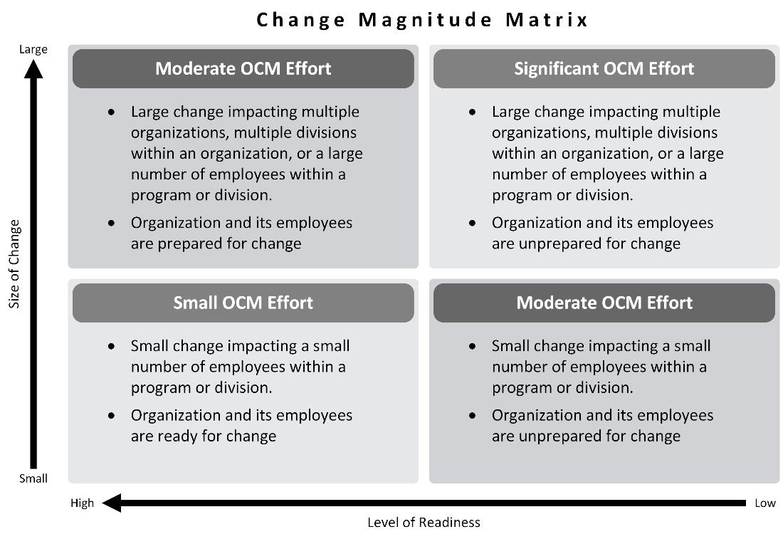

Priority Areas
[In the Priority Table below, list all OCM Environmental Areas, the scores from the Environmental Readiness Assessment, and the priority status levels. Priority status is measured as follows, based on the minimum and maximum scores possible in each environmental readiness area:]
Readiness Area Total Score | High Priority | Low Priority
Organizational Readiness Total Score | 11-22 | 23-55
Leadership Readiness Total Score | 5 – 15 | 16 – 25
Employee Readiness Total Score | 6 – 18 | 19 – 30
Supporting Infrastructure Readiness Total Score | 6 – 18 | 19 – 30
Overall Readiness Total Score | 28 – 84 | 85 – 120

Priority Area | Total Score | Priority Status
Organizational Readiness | 13 | High Priority
Leadership Readiness | 19 | Low Priority
Employee Readiness | [Enter total score] | [Enter priority status]
Supporting Infrastructure Readiness | [Enter total score] | [Enter priority status]
Overall Readiness | [Enter total score] | [Enter priority status]

Priority Activities
[This section should be completed as the project moves into the Initiating Process Phase. In the Activity Table below, list activities and corresponding priority areas. There may be multiple activities identified for each priority area.]
Priority Area | Activity
Organizational Readiness | - Facilitated sessions with key Stakeholders to discuss the business need and project priorities, develop a common understanding of the need for change, and gain commitment to the project and project outcomes
Leadership Readiness | - Facilitated sessions with executive leaders to introduce the organizational vision and need for change
Employee Readiness | - All-staff meeting where key executives build excitement for the change
Supporting Infrastructure Readiness | - Ensure business case is clearly and visibly aligned with people, processes, and strategies as they relate to the change initiative

